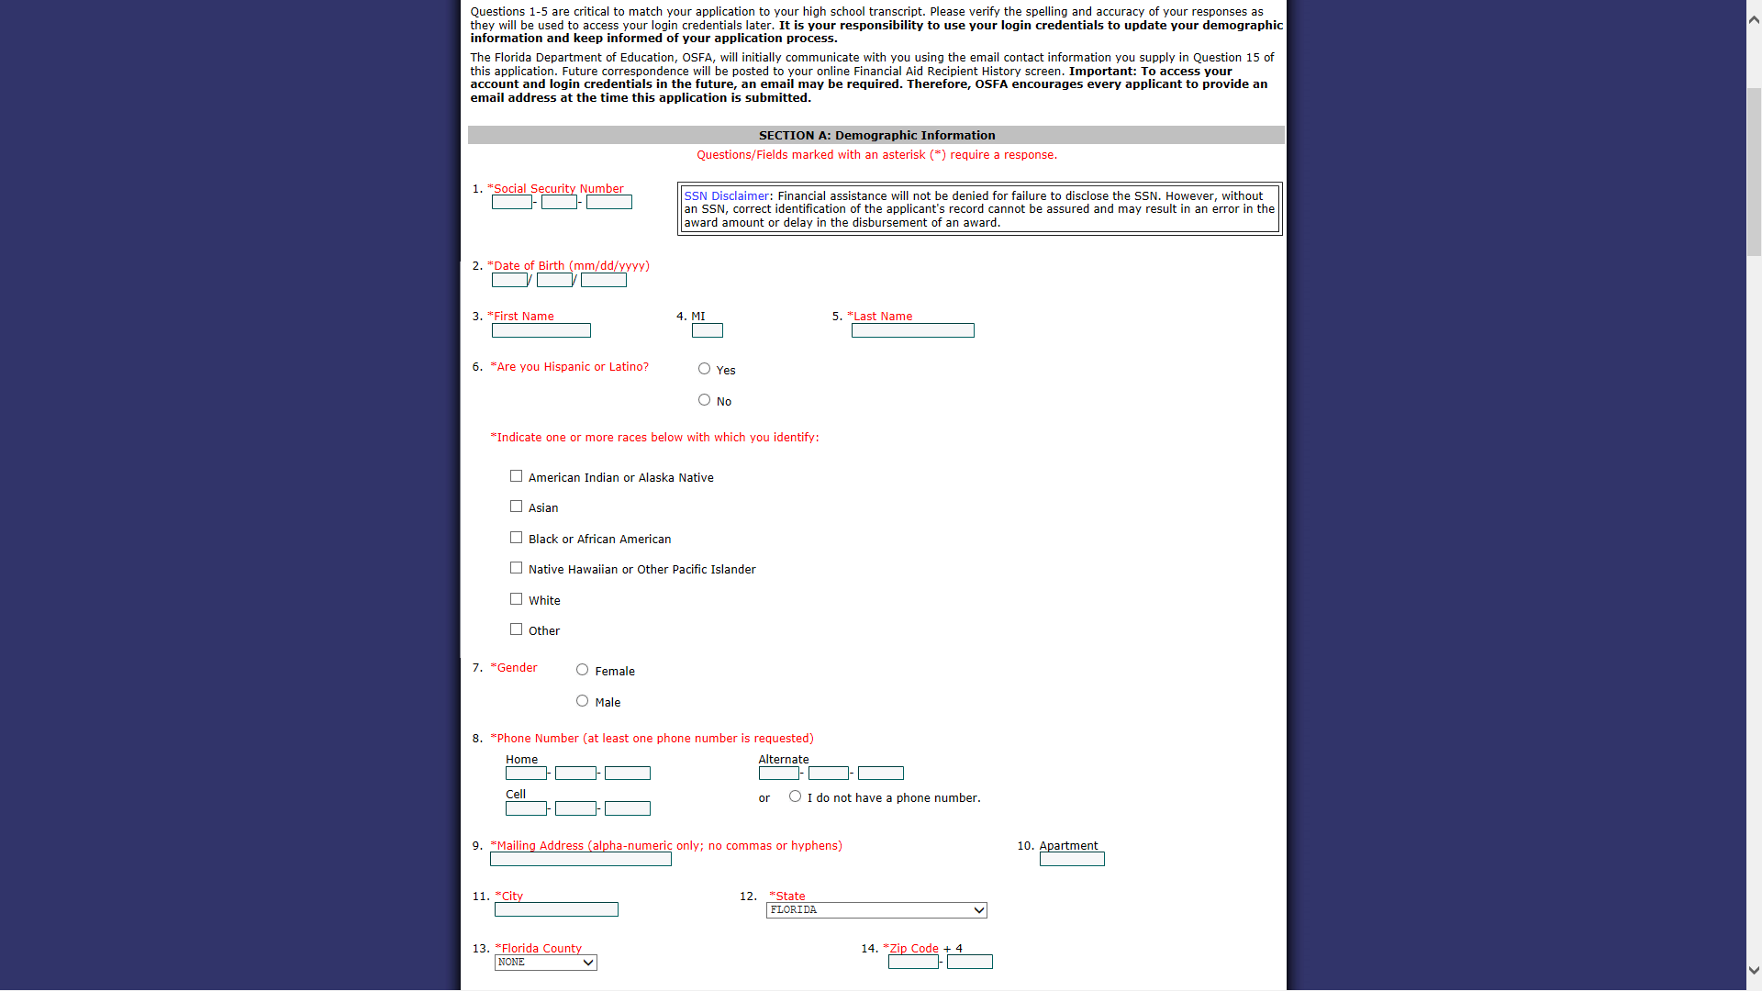

#8: Enter at least one phone number

#9 - 12: Enter your MAILING address

#13: Select “Santa Rosa County

#14: Enter your zip code

#6: Check yes or no and then check the box below that applies to you.

#7: Check appropriate box

#7:

#1: You MUST enter your correct social security number. If you’re not **sure, Guidance can provide this.**

#2: Your date of birth must be entered correctly.

#3: Your legal name must be entered exactly as it is on your birth certificate and school records.

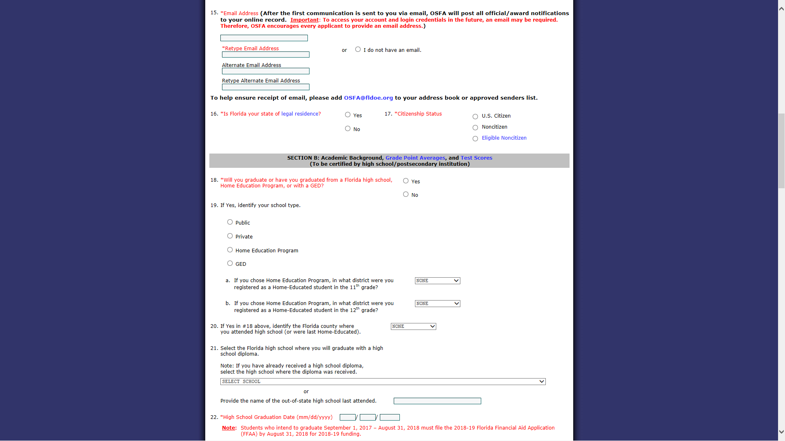

#22: Enter the date **05/26/2018**

#21: Select “Gulf Breeze High School

#20: Select “Santa Rosa”

#18: Check YES

#19 Check PUBLIC and skip a & b

#16: Check YES

#17: Check appropriate answer

#15: This is how OSFA will communicate with you regarding your Bright Futures status! Make sure you put in valid emails and check them.

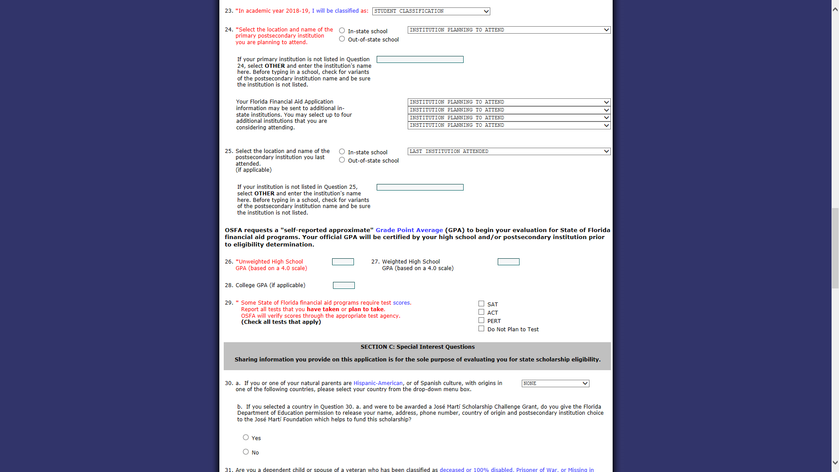

#30: ONLY answer this question if you identify with any of the countries listed. If not, SKIP this and move to # 31.

#26: Estimate your unweighted GPA

#27: Estimate your weighted GPA or leave blank if you’re unsure.

#28: Leave blank

#29 Check all tests that you have taken or plan to take

**OMIT # 25**

**# 23: EVERYONE selects “Freshman 1st time in college”**

**#24: EVERYONE checks “In-state school” and chooses the Florida college/university you plan to attend. This can be changed later.**

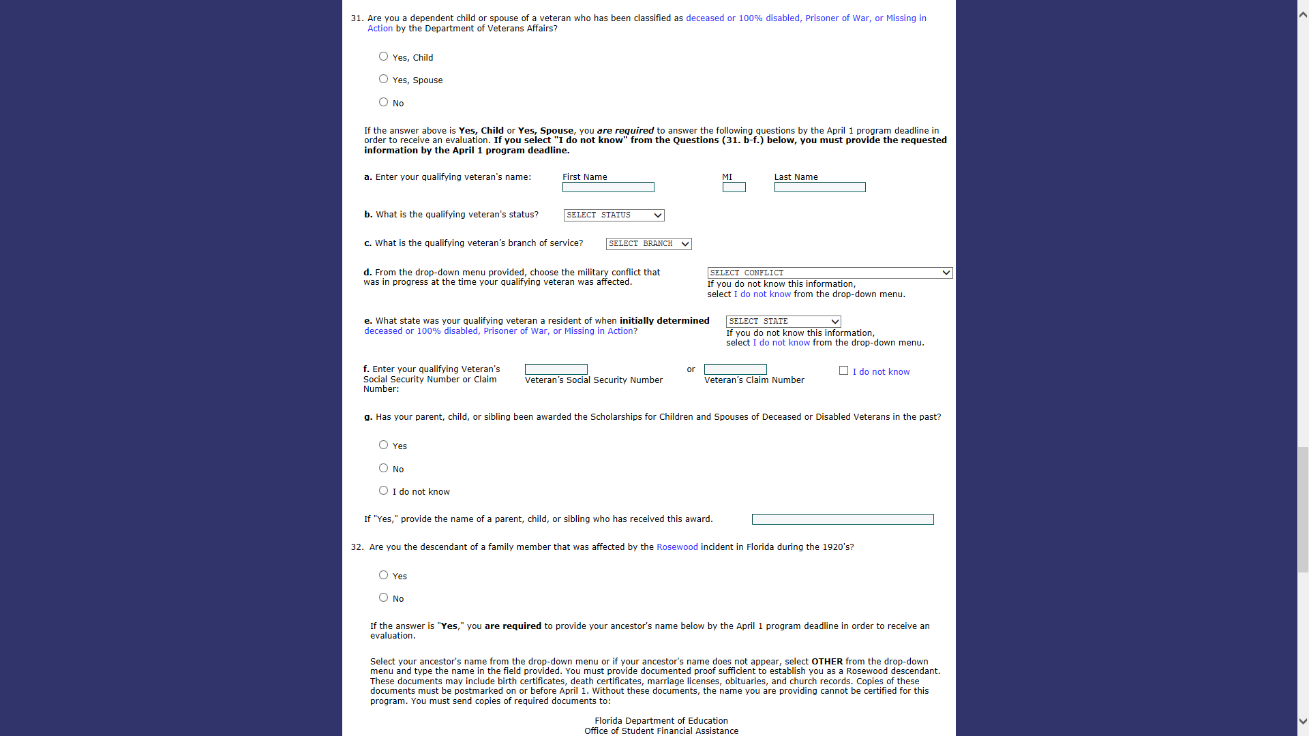

#32: Only check YES if you know for sure that this applies to you. If you aren’t familiar with this, check NO and move to #33.

#31: Check “Yes, Child” if one of your parents is a veteran who meets the criteria listed. If YES, complete questions a-g. If NO, move on to # 32.

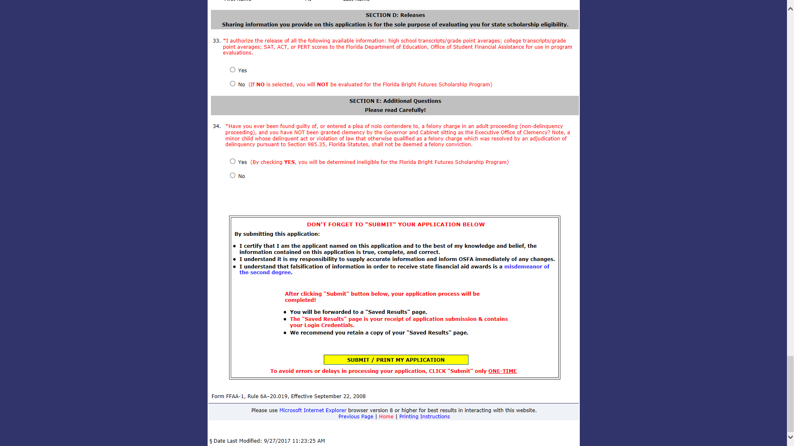

Click the yellow “Submit” box ONLY ONCE and wait for your application to process. The next screen will show a summary with your username and password. Take a photo of this screen or write down the info for future reference!

You should mark “yes” on #33

and “no” to #34 UNLESS YOU HAVE BEEN FOUND GUILTY OF A FELONY!!!